**Q1: Copy and paste the lines of code you used to specify your substitution model, the linking/unlinking of partitions, and the rate prior. Please do NOT copy and paste all of your partition information (i.e. all of the charset lines)!**

A) So we are here considering the GTR+I model which means the nst has to be set to 6 and the rates are propinv (which is invariance without gamma), unlinking is done for all the loci and rates are set to variable. The outgroup here is “Pellenes”

* Code:

lset applyto=(all) nst=6 rates=propinv;

unlink statefreq=(all) revmat=(all) shape=(all);

prset applyto=(all) ratepr=variable;

outgroup Pellenes;

**Q2: Copy and paste the lines of code you used to set up all of the node dating constraints, calibrations, and priors. (5 points)**

A) Mentioning the node dating constraints, calibrations and the priors in form of the code below:

* Code:

constraint Harbonattus = 1-12 14-16;

calibrate Harbonattus = truncatednormal(2.5,5,1.2);

constraint Harbonattus2 = 5 9 15;

calibrate Harbonattus2 = truncatednormal(2.1,4.8,1.4);

constraint Harbonattus3 = 5 9;

calibrate Harbonattus3 = truncatednormal(0.5,3.25,1.3);

constraint Harbonattus4 = 16;

calibrate Harbonattus4 = truncatednormal(1.7,2.7,0.5);

constraint Harbonattus5 = 11;

calibrate Harbonattus5 = truncatednormal(1,1.5,0.25);

prset brlenspr = clock:uniform;

prset treeagepr = offsetexp(300,390);

prset clockratepr = lognorm(-5.5,0.5);

prset clockvarpr = igr;

**Q3: Provide your plot of the Habronattus phylogeny with divergence time estimates. (4 points)**

A)

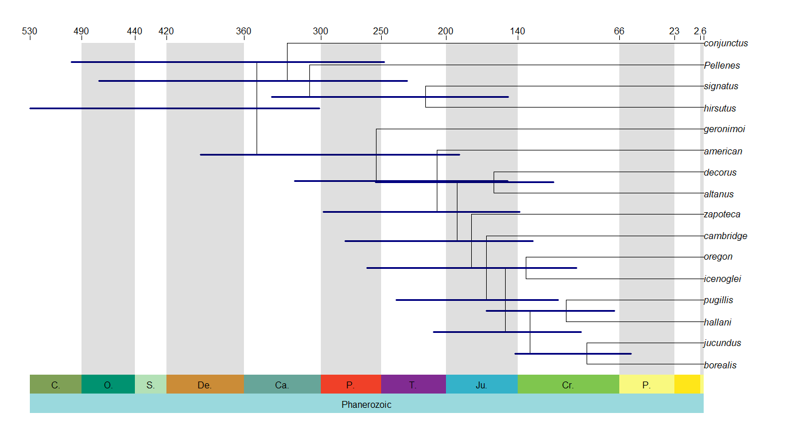Fig 3A: Geological Time Scale keeping Eon and Period in consideration

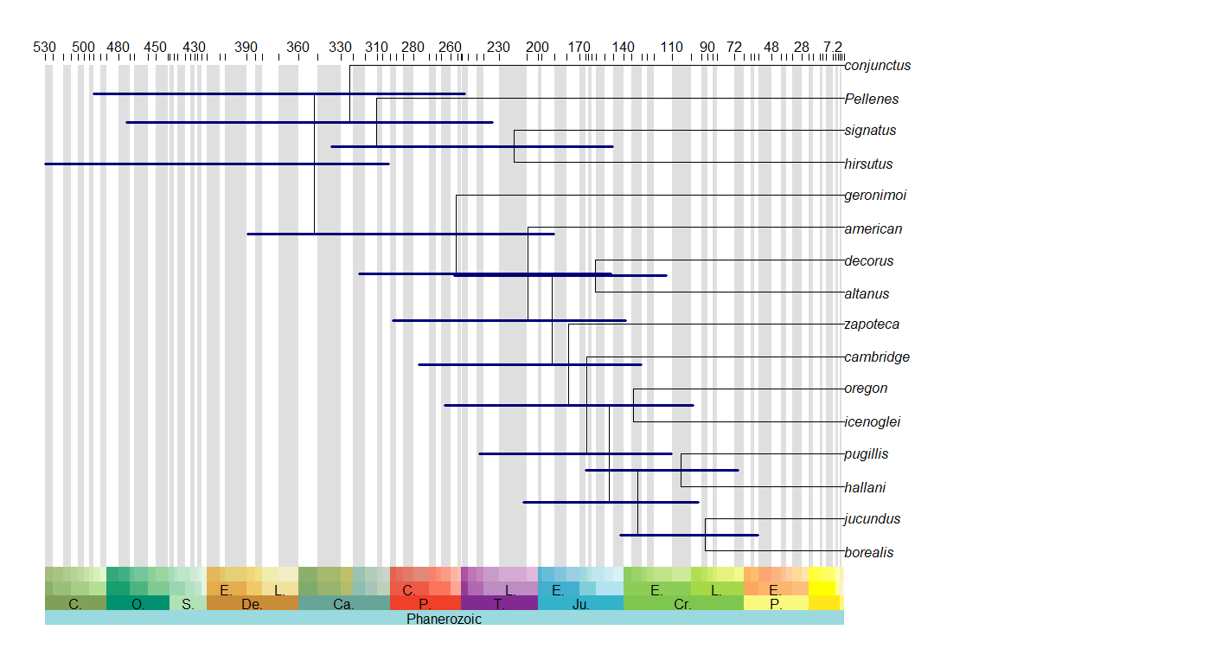

Fig 3B: Geological Time Scale keeping Eon, Period, Epoch and Age in consideration respectively (from bottom)

**Q4: Based on the results of your test, does it appear that rates are constant in this clade? (1 point)**

A)

* Code:

x <- read.nexus("spiderConcat.nex.con.tre")

bt = branching.times(x)

bt

bt = sort(bt)

diversi.gof(bt)

* Result:

Tests of Constant Diversification Rates

Data: bt

Number of branching times: 15

Null model: exponential

Cramer-von Mises test: W2 = 1.781 P < 0.01

Anderson-Darling test: A2 = 2.895 P < 0.01

* Conclusion:

As our p-value is less than the significance level, we have sufficient evidence to **reject** the null hypothesis which states that the rates are constant in this clade. Hence we conclude that the rates are not constant in this clade.

**Q5: Compare your plot from MEDUSA with your original plot with divergence times. Is there a particular point in time where diversification rates appear to increase? If so, what geological era or age does this coincide with? Does the ice age theory seem to be supported? Why or why not? (4 points)**

A)

* Code:

BiocManager::install("geiger")

library(geiger)

n.taxa = c("5,1,2,1,2,9,1,2,2,2,1,2,2,1,3,14")

richness = data.frame(taxon=x$tip.label, n.taxa=n.taxa)

medusa.res = medusa(x, richness=richness, warnings=FALSE)

plot(medusa.res, label.offset=0.5, edge.width=2)

If we see the Medusa plot, we understand that the clade for species jucundus and borealis is highlighted in red showing an increase in the diversification rates. Comparing this plot to the previous original plot containing geological time scale details, we find that this falls under the **Phanerozoic eon with the Era being mesozoic, period being Cretaceous (and extending to Paleogene) and the epoch states Eocene and Lower**.

During the **Mesozoic**, which consisted of the Triad, Jura and Cretaceous periods, and lasted from 225 until 65 million years ago, there were barely any ice ages. It was an era during which many sorts, among which reptiles, dinosaurs, ammonites, fish, mammals, birds and broad-leaved trees, flourished in numbers and variety. The last ice-age occurred in the **Pleistocene epoch**, which was much after the Cretaceous period. Hence, we can not say here that the ice age was the reason for the high diversification rates during and post the Cretaceous period.

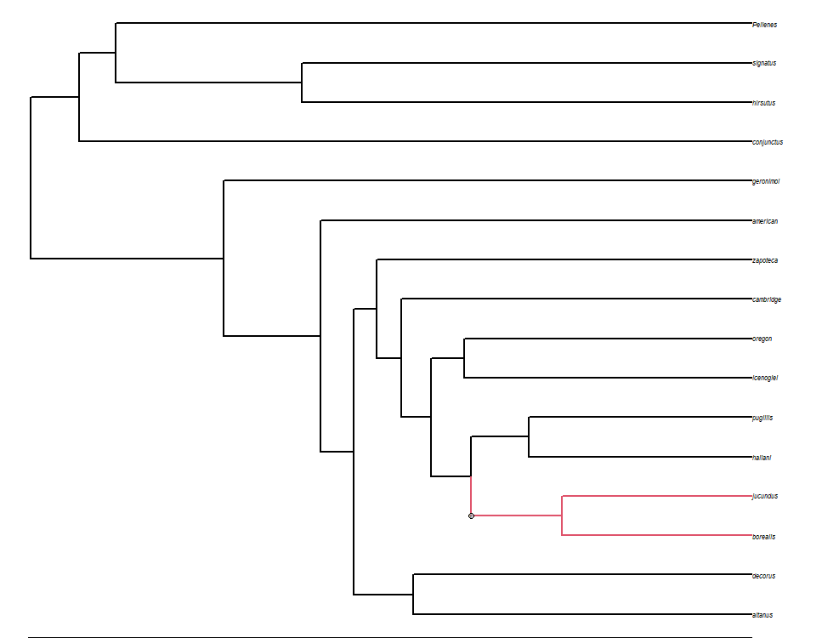

Fig 5A: The Medusa Plot



Fig 5B: The enlarged Medusa Plot

Q6: Provide the plot of your SVDQuartets tree. (1 point)

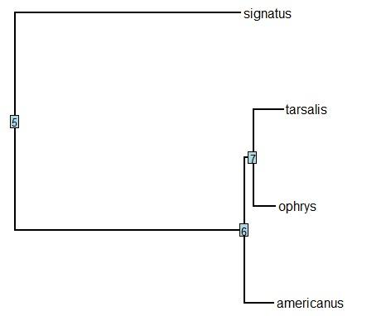

Fig 6: SVDQuartets tree

**Q7: What are your species assignments for P1, P2, and P3? (2 points)**

A) Referring to Fig 6, the sp. Tarsalis is P1, Ophrys is P2 and Americanus is P3 with the outgroup Signatus.

**Q8: Is there evidence of gene flow between any of these species? If yes, then which pair of species is exchanging genes? (2 points)**

A)

* Code:

> library(evobiR)

> ordered.names = c("tarsalis", "ophrys", "americanus", "signatus")

> spidertree2= as.DNAbin(read.nexus.data("spider-snps.nex"))

> m = match(ordered.names, labels(spidertree2))

> new.dna.bin = spidertree2[m]

> write.FASTA(new.dna.bin, file="spidertree.fa")

> CalcD(alignment="spidertree.fa", sig.test="B")

* Result:

performing bootstrap....................................................................................................

Sites in alignment = 50000

Number of sites with ABBA pattern = 554

Number of sites with BABA pattern = 321

D raw statistic / Z-score = 0.2662857 / 8.195957

Results from 1000 bootstraps

SD D statistic = 0.03248989

P-value (that D=0) = 2.220446e-16

* Conclusion:

As our p-value is less than the significance level, we have sufficient evidence to **reject** the null hypothesis which states that there is gene flow between any of the species. Hence we conclude that the species lack any kind of gene flow.